Linux Task 01: Linux Environment Setup & Essential Commands
Part A: Linux Installation & Verification
• Kali Linux on VM
- Desktop Environment Screenshot
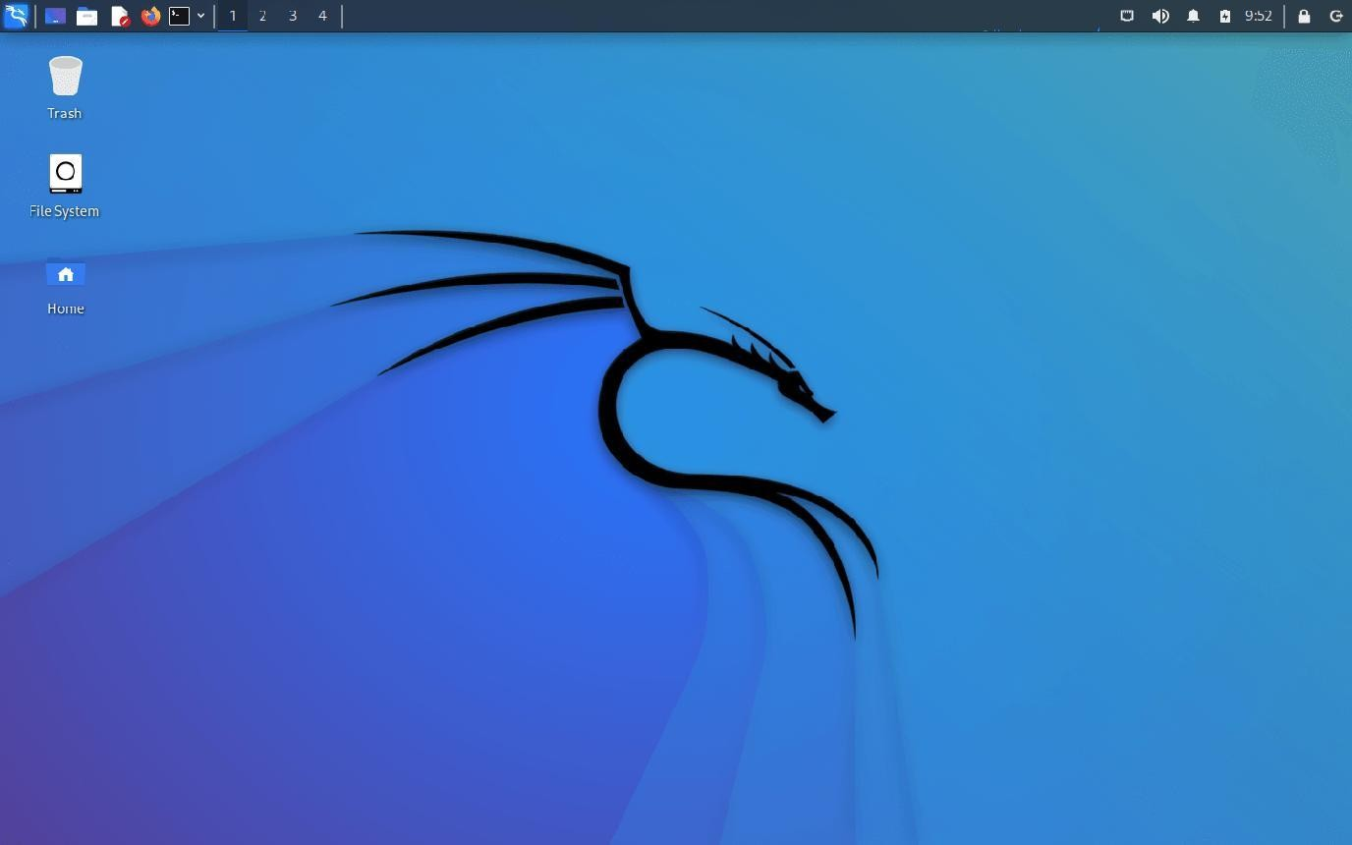

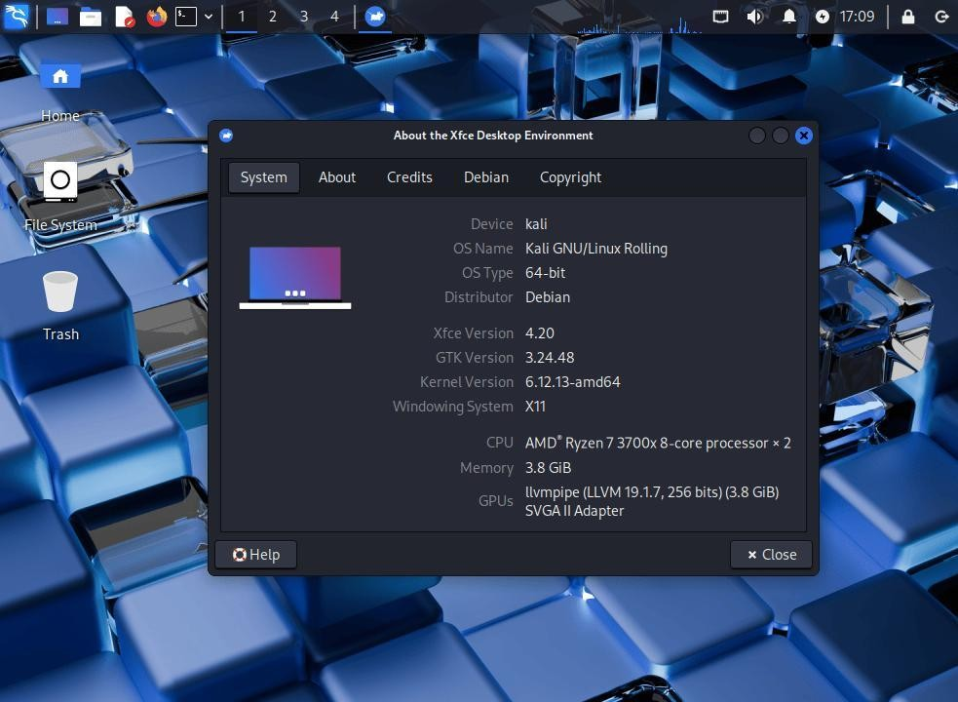
- Terminal Window Screenshot
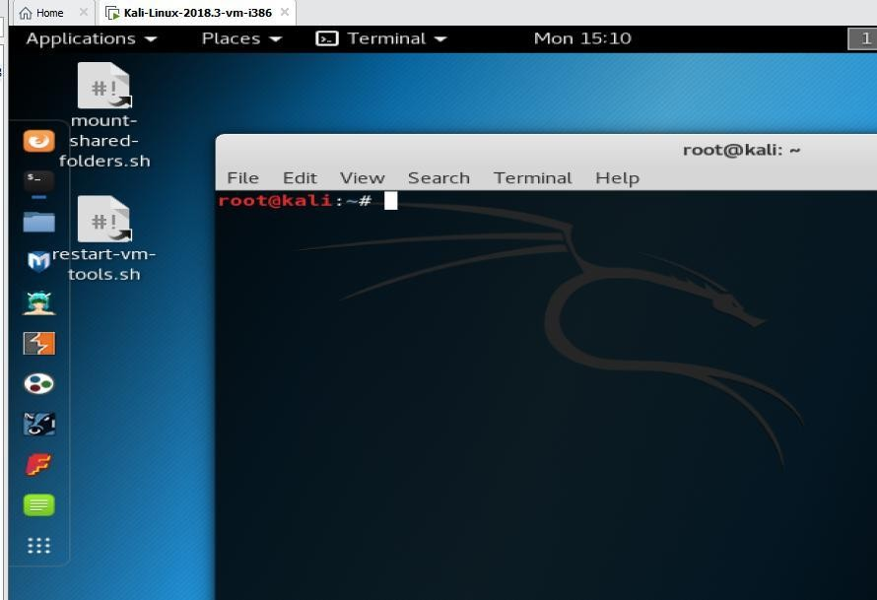

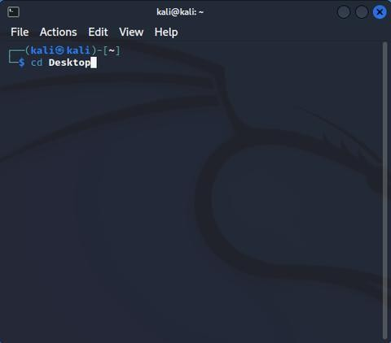

- System Information Screenshot
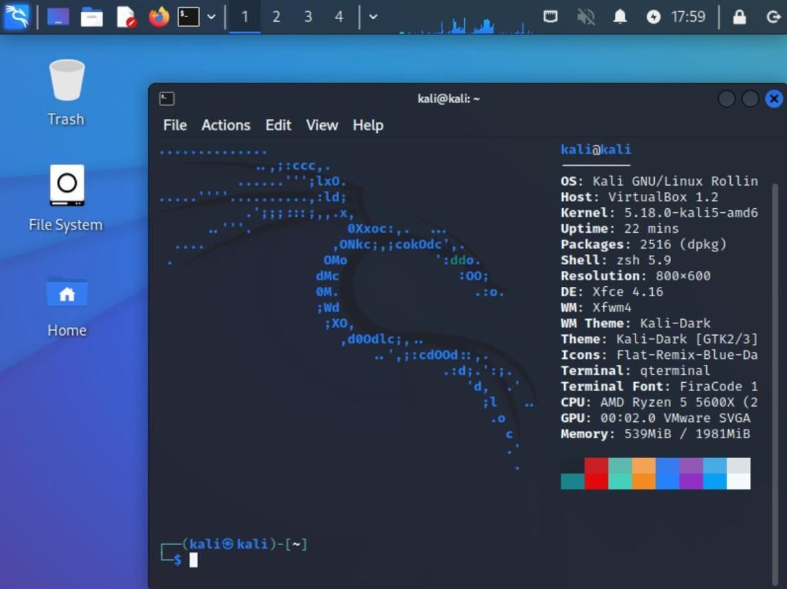

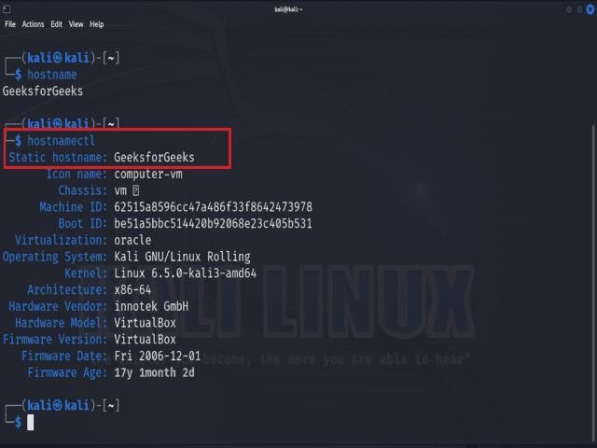

Part B: Basic Navigation Commands
1.Pwd
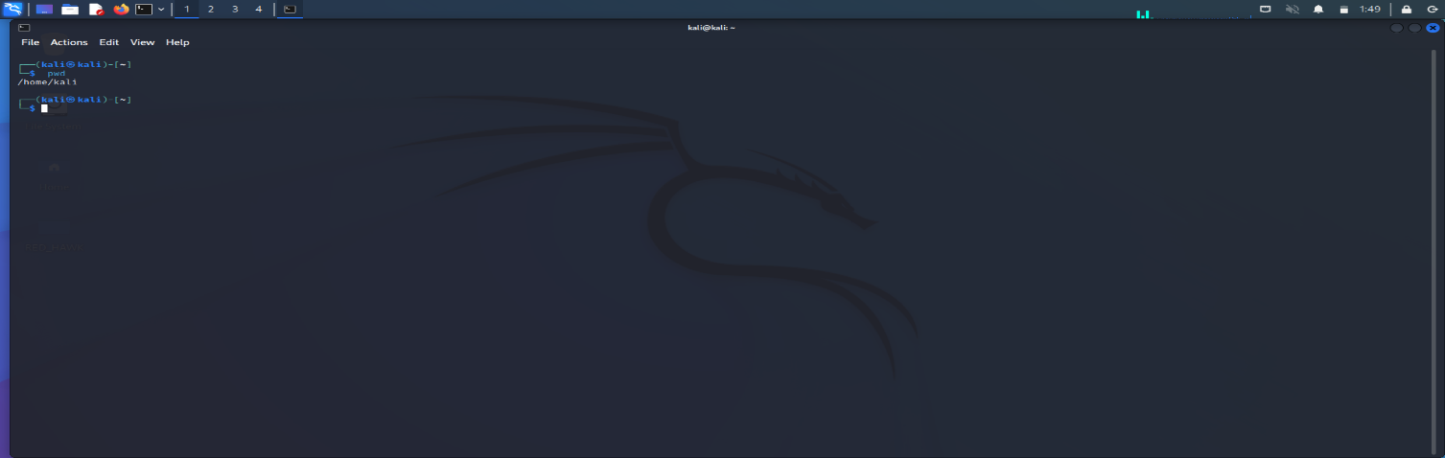
Purpose:-Displays the Present Working Directory, showing the current directory path.
2.ls 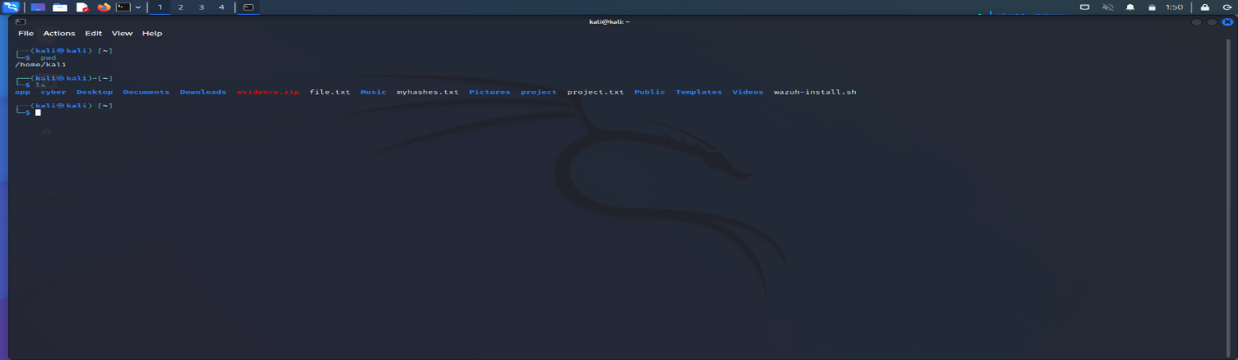
Purpose:-Lists the files and directories in the current directory.
3.ls -la 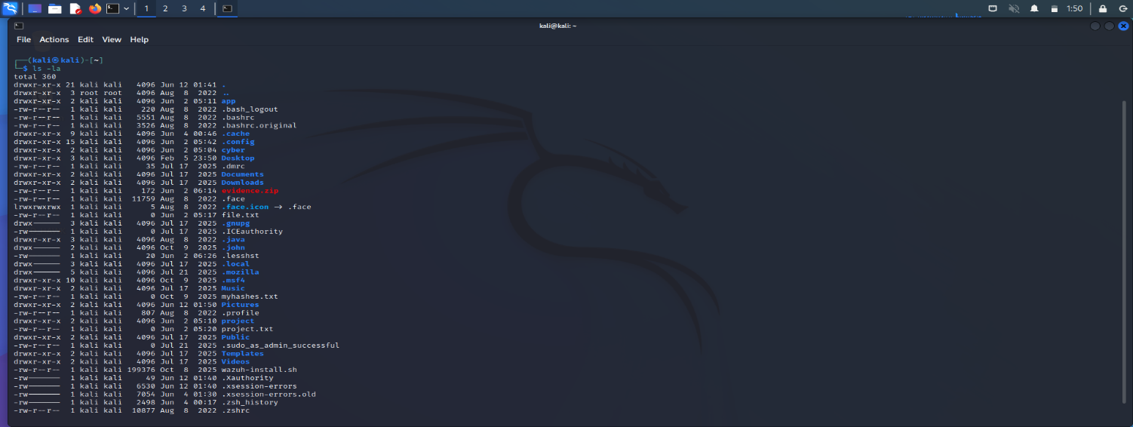
Purpose:-Displays a detailed list of all files and directories, including hidden files, permissions, owner, size, and modification date.
4.cd 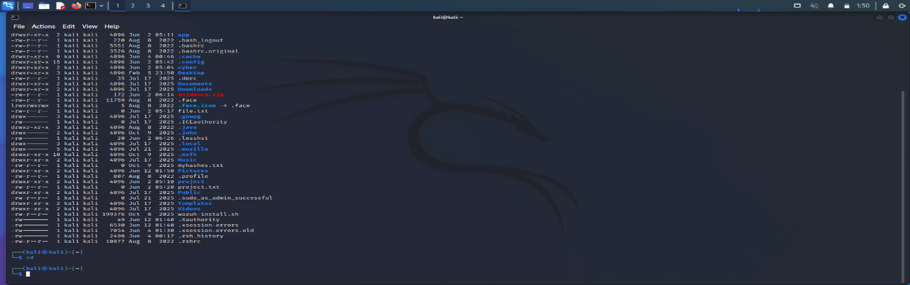
Purpose:-Changes the current directory. Without arguments, it usually returns to the user's home directory.
5.clear 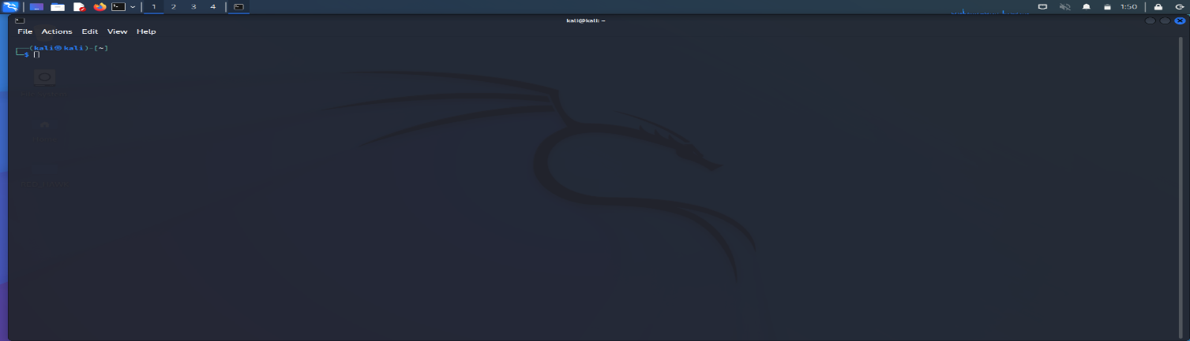
Purpose:-Clears the terminal screen and provides a clean workspace.
6.history 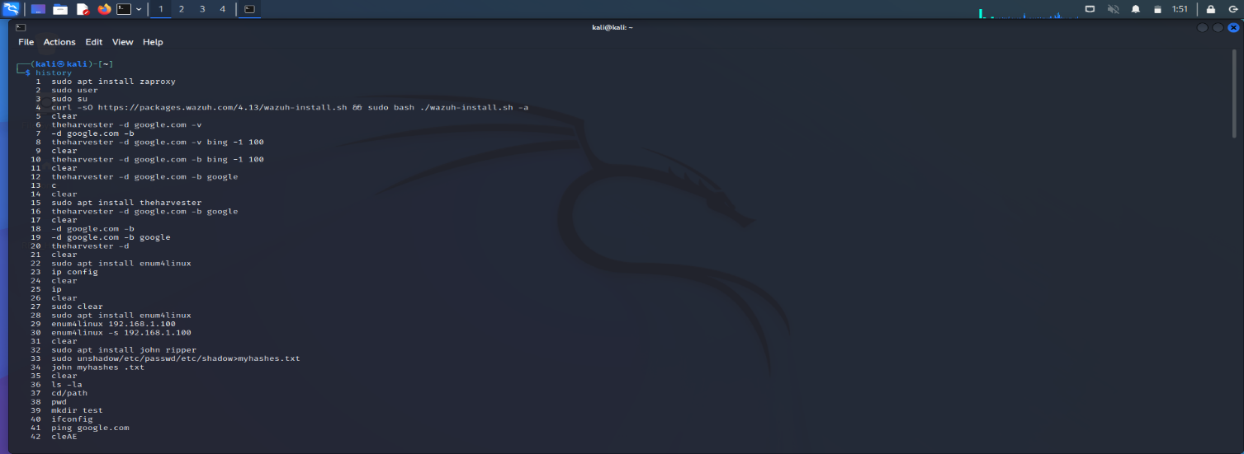
Purpose:-Shows a list of previously executed commands in the terminal.
7.whoami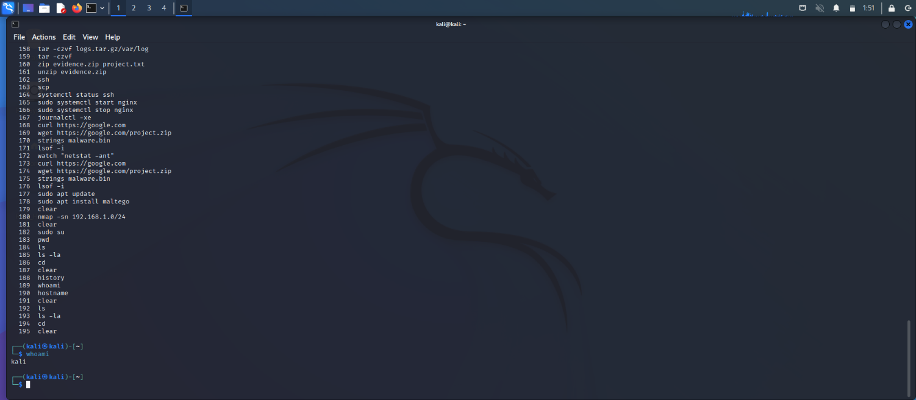
Purpose:-Displays the username of the currently logged-in user.
8.hostname 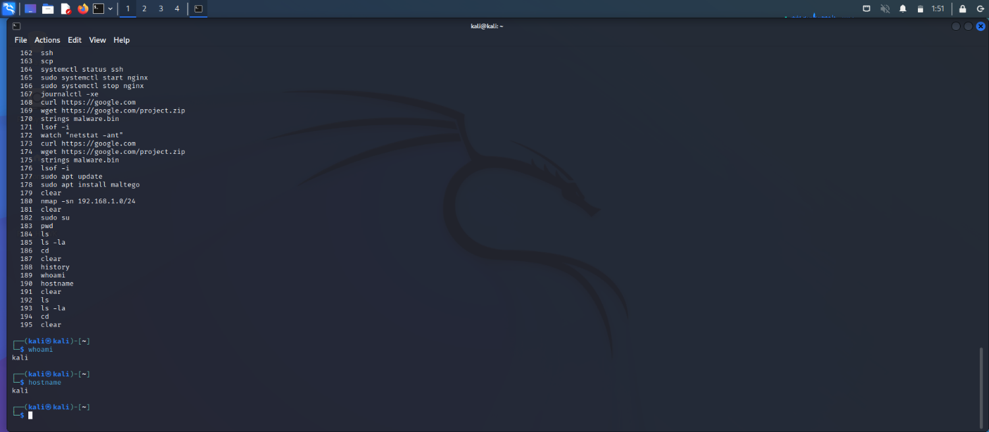
Purpose:-Displays the system's hostname (computer/network name).

Part C: Directory Management
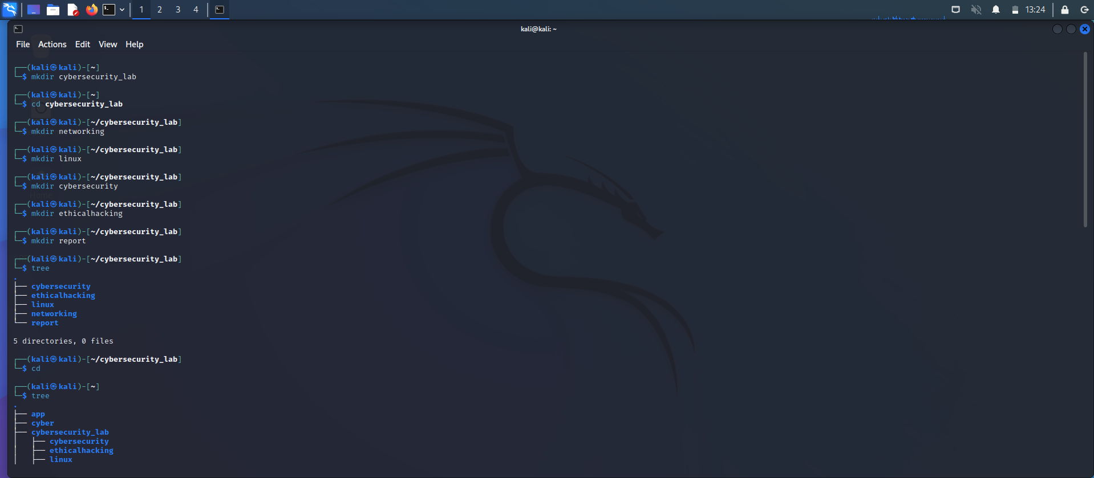
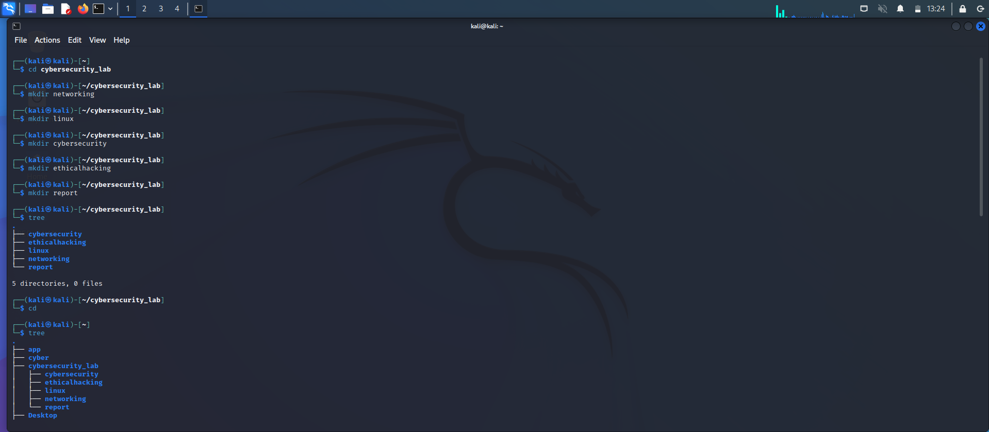

Part D: File Management
1. touch Command
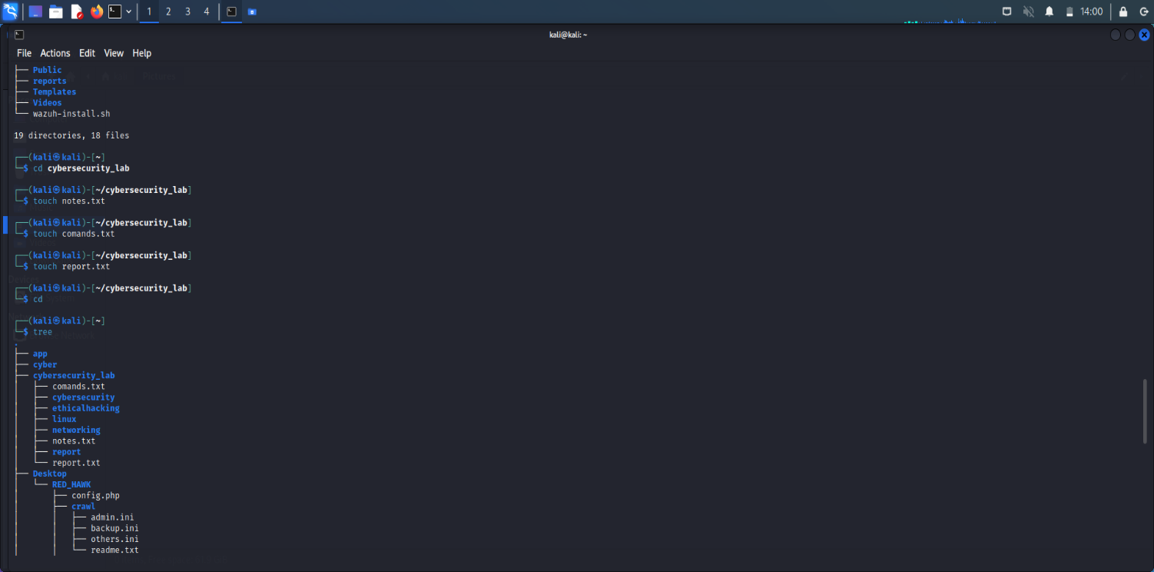
Purpose: Creates a new empty file.
2. cp Command
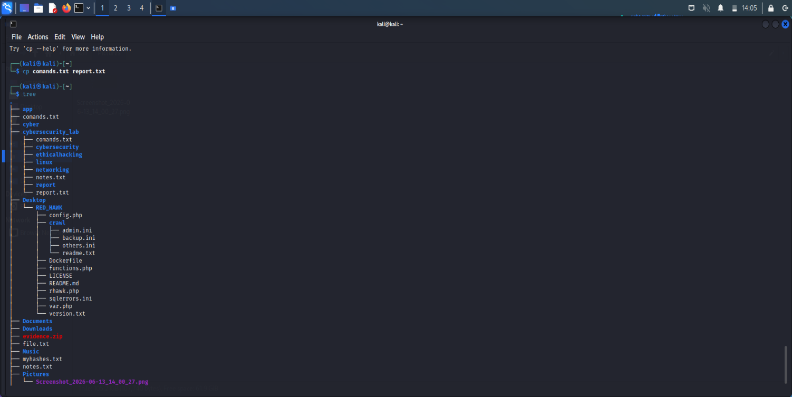
Purpose: Copies files or folders from one location to another.
3. mv Command
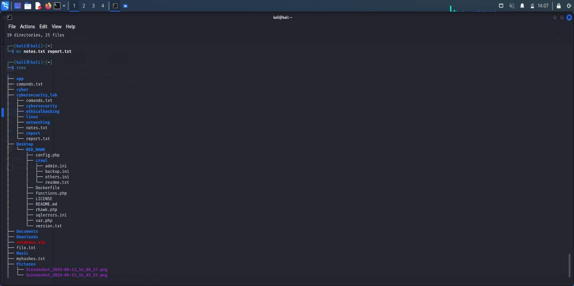
Purpose: Moves a file/folder or renames it.
4. rm Command
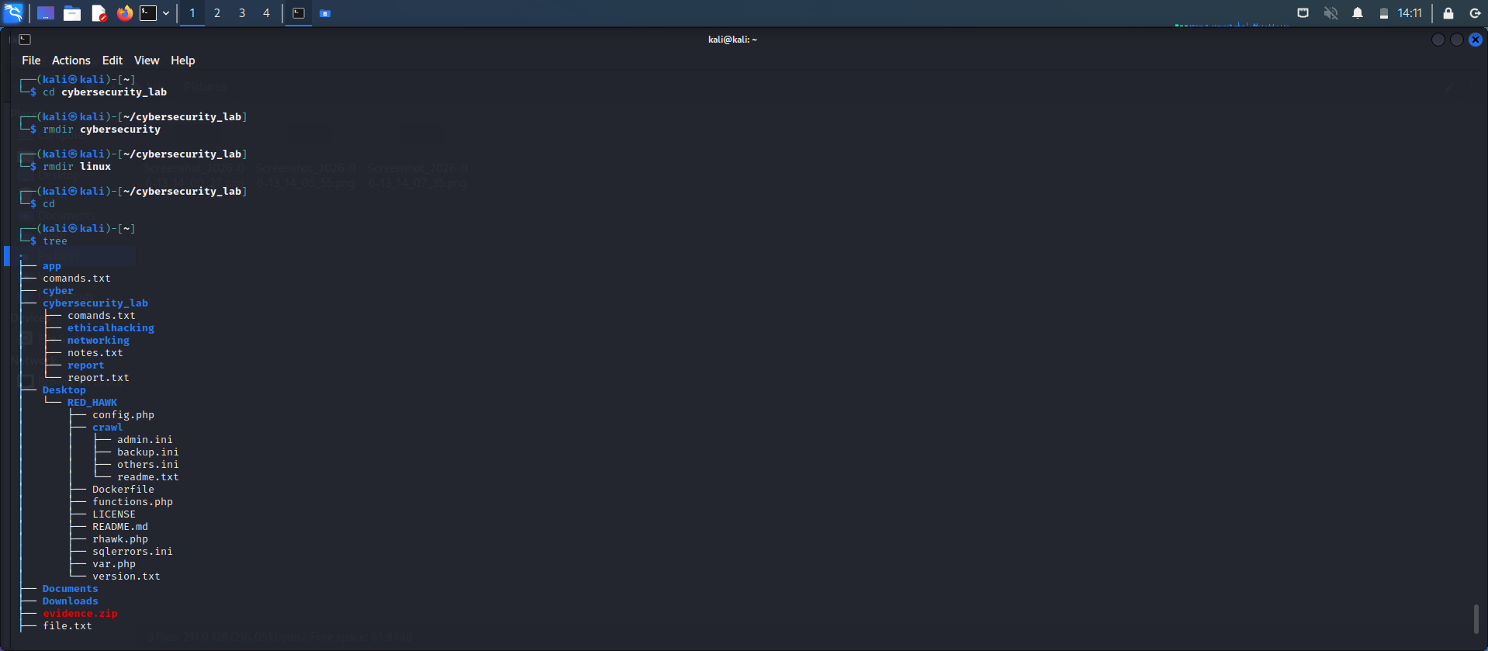
Purpose: Deletes files or folders.

Part E: System Information Collection
1.uname -a
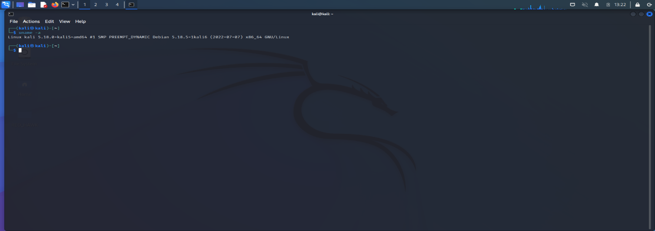
2.hostname
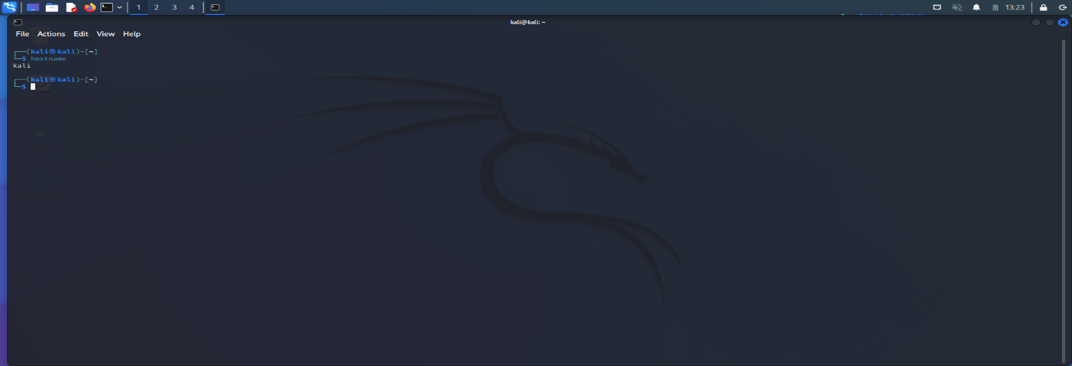
3.whoami
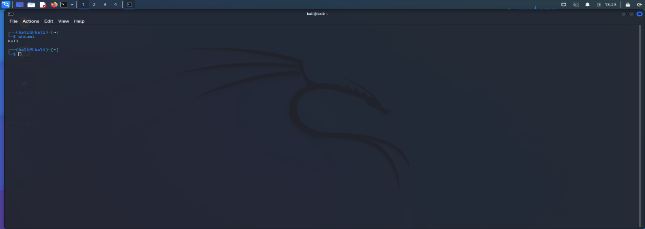
4.date
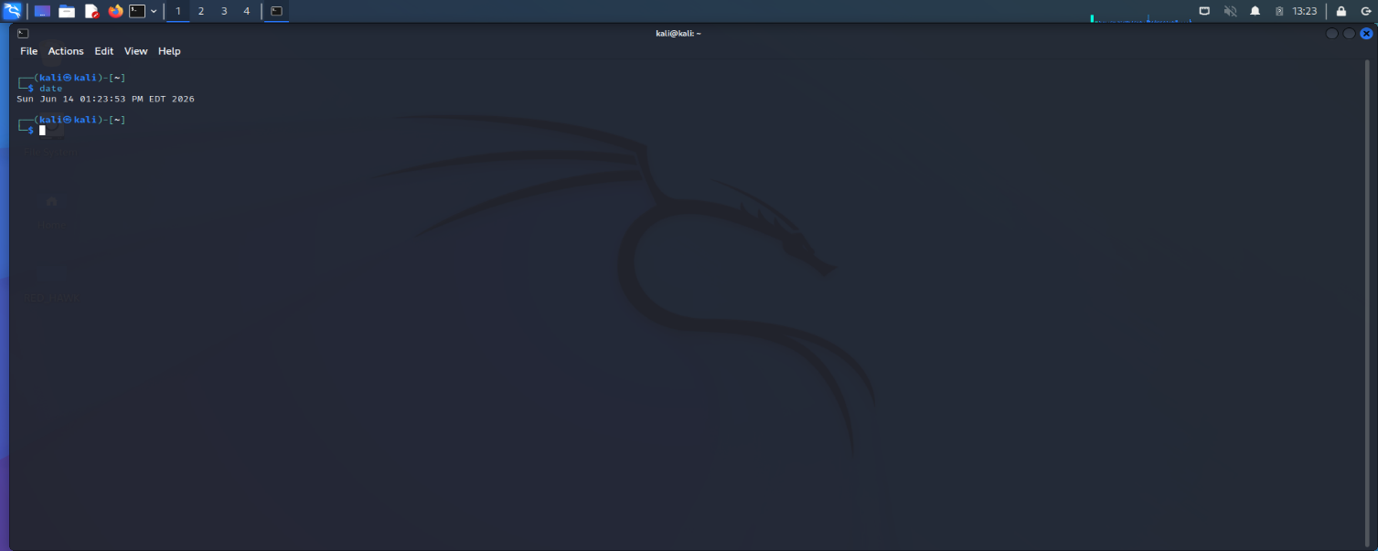
5.uptime
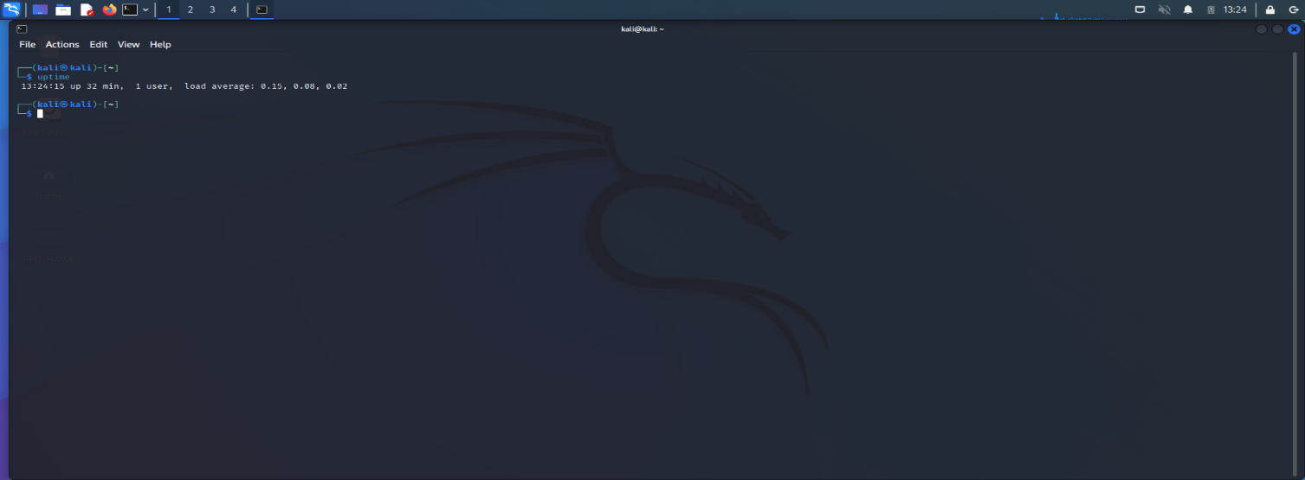
6.pwd
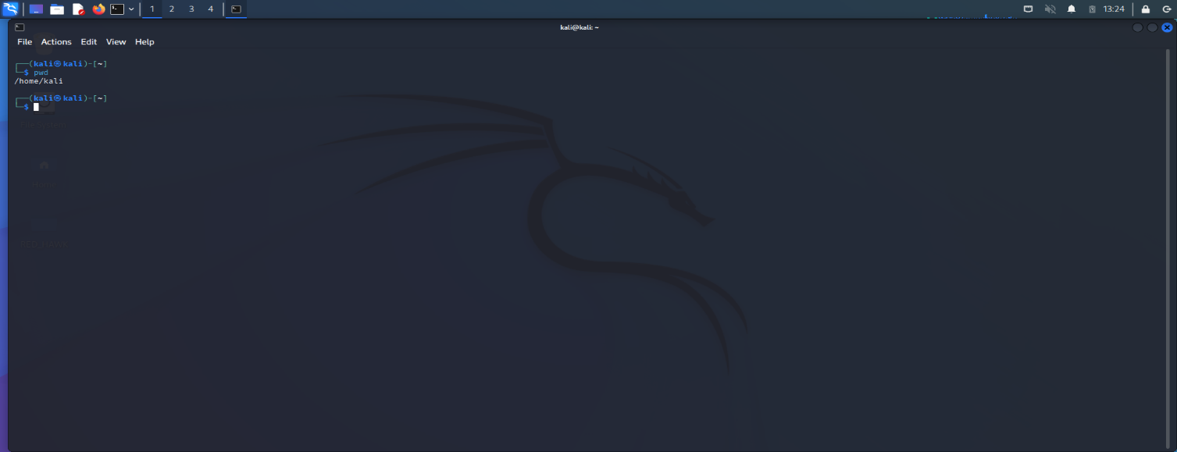
Part F: Linux Research Activity
1. What is Linux?
Linux is a free and open-source operating system that manages computer hardware and software resources. It was created by Linus Torvalds in 1991. Linux acts as a bridge between the user and the computer hardware, allowing users to run applications, manage files, and perform various tasks. It is widely used in personal computers, servers, mobile devices, and cloud systems. Since its source code is publicly available, anyone can modify and improve it according to their needs. Linux is known for its stability, security, and efficiency, making it one of the most popular operating systems in the world.
2. Why is Linux Important in Cyber Security?
Linux is very important in cyber security because it provides a secure and flexible environment for security professionals. Most security tools such as penetration testing, vulnerability assessment, and network monitoring tools are designed to work efficiently on Linux. Linux allows users to customize system settings and security configurations according to their requirements. Many web servers and cloud platforms run on Linux, so understanding Linux helps security experts identify and fix vulnerabilities. Its strong permission system and open-source nature also help security researchers analyze and improve system security.
3. Difference Between Linux and Windows
Linux and Windows are two popular operating systems, but they differ in several ways. Linux is open-source and free to use, while Windows is proprietary software that requires a license. Linux provides more control and customization options, whereas Windows is generally easier for beginners due to its user-friendly graphical interface. Linux is considered more secure because malware and viruses target it less frequently. Windows is widely used for gaming and office work, while Linux is commonly used in servers, networking, and cyber security. Linux supports command-line operations extensively, whereas Windows relies more on graphical tools.
4. What is a Linux Distribution?
A Linux Distribution, often called a Linux distro, is a complete operating system built using the Linux kernel along with software packages, utilities, and graphical interfaces. Different distributions are designed for different purposes and users. Some popular Linux distributions include Ubuntu, Kali Linux, Debian, and Fedora. Each distribution provides unique features, software repositories, and user experiences. For example, Kali Linux is specially designed for ethical hacking and penetration testing, while Ubuntu is known for its ease of use. Linux distributions allow users to choose an operating system that best suits their needs.

5. Why do Ethical Hackers Prefer Linux-Based Operating Systems?
Ethical hackers prefer Linux-based operating systems because they provide powerful tools and flexibility for security testing. Linux allows easy access to system files and configurations, which helps in analyzing and securing systems. Many ethical hacking tools are either built for Linux or work better on Linux environments. Linux also offers better command-line capabilities, making automation and scripting easier. Operating systems like Kali Linux come pre-installed with hundreds of security tools used for penetration testing, digital forensics, and vulnerability assessment. Additionally, Linux is stable, secure, and widely used in servers and networks, making it an ideal platform for cyber security professionals.

